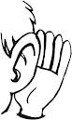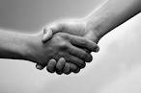
listen raise our hands are friends
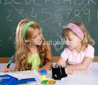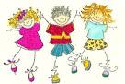
help each other try our best & have fun.

